ArcheGEO User Guide
- Landing Page
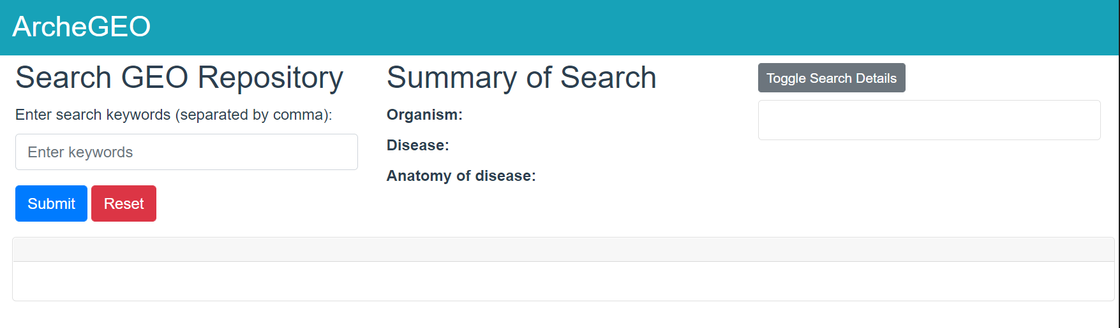
- Performing a search
- Input search keywords separated by commas (e.g., human, lung cancer, prostate cancer)
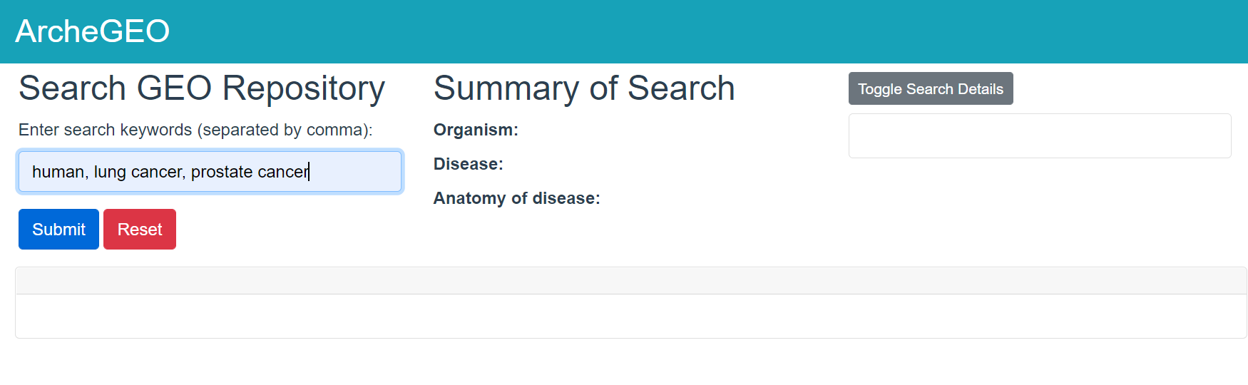
- Click “Submit” button
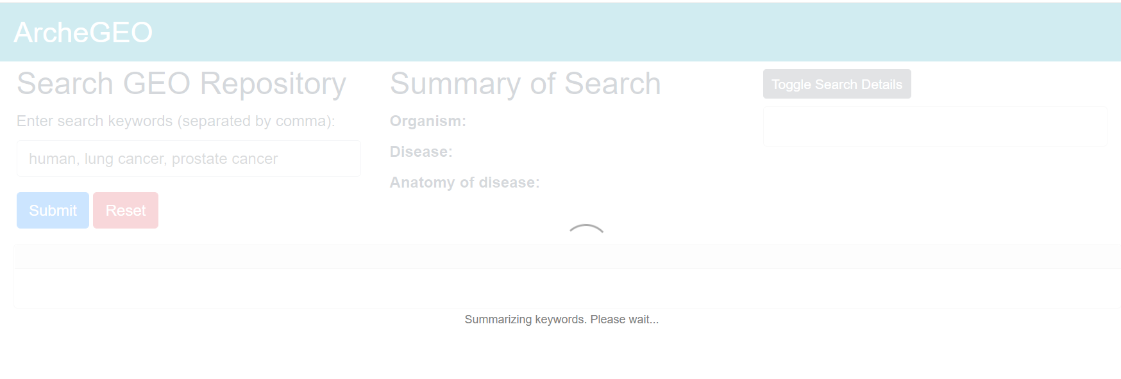

The result is presented in several panels:
- Panel 1: summarizes the keywords into three categories (i.e., organism, disease and anatomy of disease)
- Panel 2: reports the queries submitted to PostgreSQL, the total number of results returned and out of these results, the ones that are validated to be relevant by ArcheGEO.
- Panel 3: shows the list of records for each of these queries (each query is represented as a tab). Only relevant results are presented in the tab. Users can view the Invalid Records by clicking on the “View invalid records” button.

A row of buttons (Panel 4) is found at the bottom of each tab. Some buttons may be found only in certain tabs.

- Select all: Selects all GDS records in the current tab.
- Clear selected: Clears all selection in the current tab.
- View invalid records: Generate the invalid records and display it as a separate tab
- Download SOFT: Download the SOFT files for all selected GDS records.
- Set as invalid records: Set selected valid records as invalid records. Note that the reason of why record is invalid has to be set by the user and will be updated to the view table in PostgreSQL.
- Set as valid records: Set selected invalid records as valid records.
- Save results: Save the list of GDS records in the current tab as a .xlsx file.
- Close tab: Closes the current tab. This button is only shown when the current tab is a user created tab (i.e., to combine results for display).

Further, there are several state for the Validity dropdown selection box:
- [Valid]: the annotated organism of the current GDS record corresponds to the organism keyword AND the inferred disease(s) of the current GDS record corresponds to the disease keyword.
- [Organism Valid, Disease Mismatch]: the annotated organism of the current GDS record corresponds to the organism keyword AND the inferred disease(s) of the current GDS record do not correspond to the disease keyword.
- [Organism Valid, Disease Unverified]: the annotated organism of the current GDS record corresponds to the organism keyword AND disease(s) cannot be inferred for the current GDS record.
- [Organism Mismatch, Disease Valid]: the annotated organism of the current GDS record do not correspond to the organism keyword AND the inferred disease(s) of the current GDS record corresponds to the disease keyword.
- [Organism Mismatch, Disease Mismatch]: the annotated organism of the current GDS record do not correspond to the organism keyword AND the inferred disease(s) of the current GDS record do not correspond to the disease keyword.
- [Organism Mismatch, Disease Unverified]: the annotated organism of the current GDS record do not correspond to the organism keyword AND disease(s) cannot be inferred for the current GDS record.

Although there are options of [Organism Unverified, Disease Valid], [Organism Unverified, Disease Mismatch] and [Organism Unverified, Disease Unverified], these options are technically not applicable to GDS records since every GDS record has an associated organism. In the case of keywords with no mention of organism, then the ArcheGEO assumes that no organism related check is required (i.e., any organism is valid). In ArcheGEO, an irrelevant record (i.e., invalid record) is one where at least organism is mismatched or disease is mismatched. All other types of validity are considered relevant records to cater to the ambiguity of natural language description used to describe the title and summary of the GDS record, from which the disease term of the GDS record is inferred.

- Modifying the relevance of the GDS records
Since ArcheGEO relies on a NLP-based algorithm for inferring the disease terms of a given GDS record, it is likely that some GDS records are wrongly assigned relevance labels by ArcheGEO. Users can easily select these GDS records, modify their relevance by changing the Validity options of a given record and then selecting the “Set as invalid records” or “Set as valid records” buttons.

- Configuring new result views
ArcheGEO provides flexibility on how users would like to view the results by allowing them to create new tab views (by clicking on the + tab) and specifying how the generated results obtained by ArcheGEO (original set of result tabs) should be combined (using NOT, AND and OR operators).

Upon clicking the + button (circled in red), a dialog will be shown to allow user to configure this new view tab.
The user need to specify the tab name (e.g., prostate and lung) and to specify the rules for generating the new view tab.
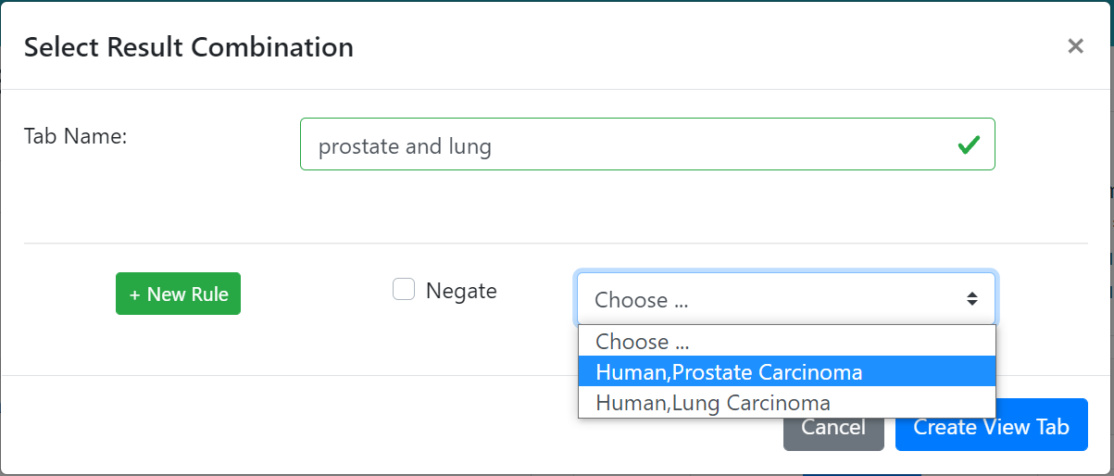
The user can modify the rules by reordering it, deleting it or editing it. Once the rules are finalized, click on “Create View Tab” to create the new tab.
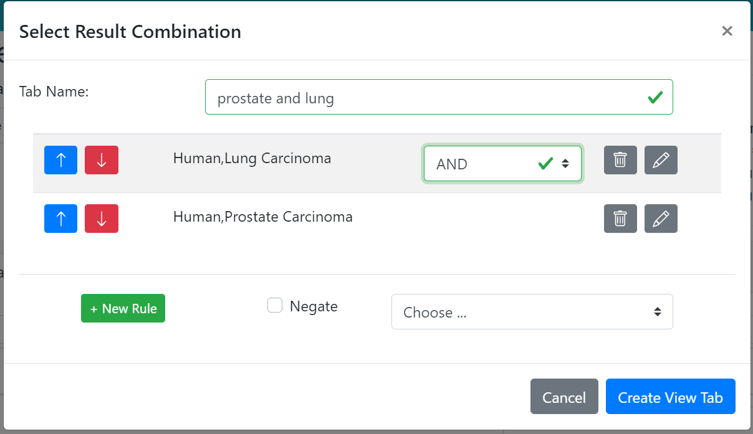

The new view tab will be displayed next to the existing tabs.
